WEEK 11 – PROJECT REPORT
AUTOMOBILE DATA CLEANING & TRANSFORMATION USING POWER BI
1. INTRODUCTION
Data cleaning and transformation are important steps in data analysis. Raw datasets may contain missing values, invalid data, and incorrect data types. In this project, the Automobile Dataset is cleaned and transformed using Microsoft Power BI. Power Query is used to prepare the data, and DAX is used to create measures for analysing automobile features such as price, horsepower, engine size, and fuel efficiency.
2. AIM
To clean, transform, and prepare the Automobile Dataset using Power BI for effective data analysis.
3. OBJECTIVES
- To identify and replace invalid values.
- To handle missing values.
- To change appropriate data types.
- To create calculated columns.
- To categorize vehicles based on their features.
- To create DAX measures for automobile analysis.
4. TOOLS USED
- Microsoft Power BI
- Power Query Editor
- DAX (Data Analysis Expressions)
- Automobile Dataset
5. DATA CLEANING
The following data cleaning operations were performed using Power Query:
- Replaced invalid values (?) with null.
- Identified and handled missing values.
- Changed numerical columns into appropriate data types.
- Cleaned and prepared the automobile data for analysis.
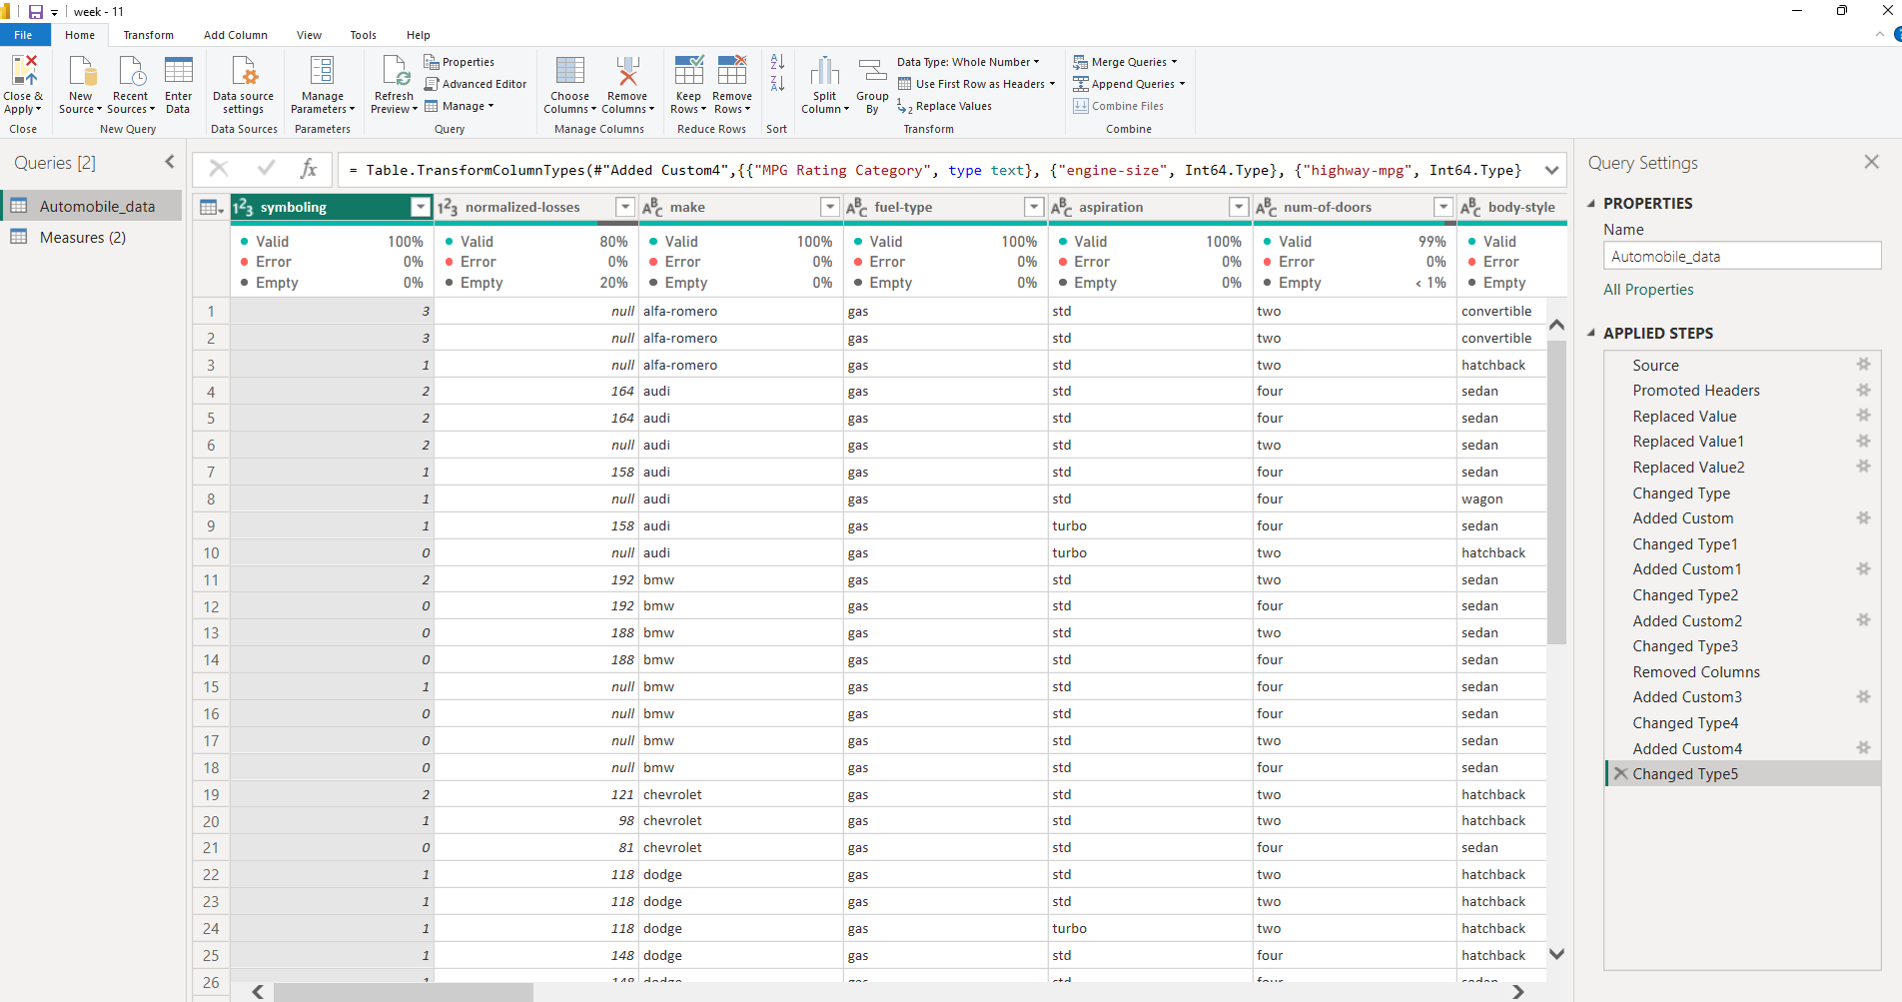6. FEATURE ENGINEERING
Three new calculated columns were created.
1. Price per Horsepower
Formula: Price / Horsepower
Used to calculate the price per unit of engine horsepower.
2. Power-to-Weight Ratio
Formula: Horsepower / Curb-weight
Used to compare engine power with vehicle weight.
3. MPG Rating Category
Vehicles were classified based on highway mileage:
- Low – Below 20 MPG
- Medium – 20 to 29 MPG
- High – 30 MPG and above
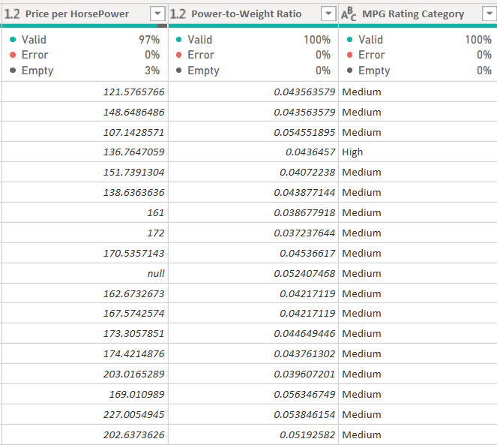
7. VEHICLE CATEGORIZATION
Vehicles were categorized based on the following features:
- Body Style
- Drive Wheels
- Fuel System
This categorization helps compare different types of automobiles.
8. DAX MEASURES
Four DAX measures were created for automobile analysis:
- Average Price
- Average Horsepower
- Average Engine Size
- Average Highway MPG
These measures help analyse vehicle pricing, engine performance, and fuel efficiency.
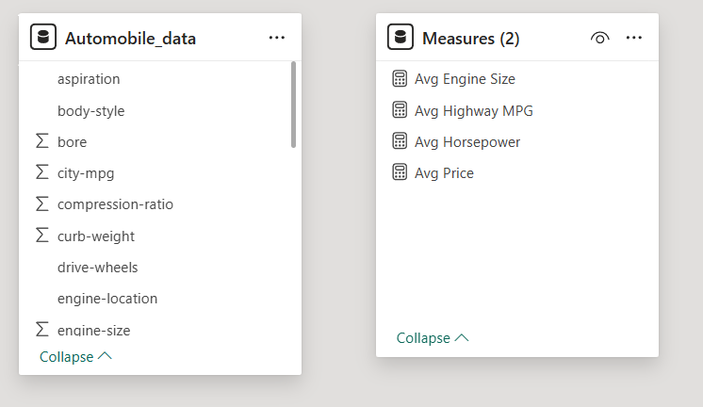9. RESULT
The Automobile Dataset was cleaned and transformed using Power BI. New calculated columns, vehicle categories, and DAX measures were prepared for further analysis.
10. CONCLUSION
The Automobile Data Cleaning and Transformation project was carried out using Power Query and DAX in Power BI. The prepared dataset provides useful information about automobile pricing, engine performance, and fuel efficiency. This dataset can be used to develop an interactive Automobile Analytics Dashboard in the next stage.

